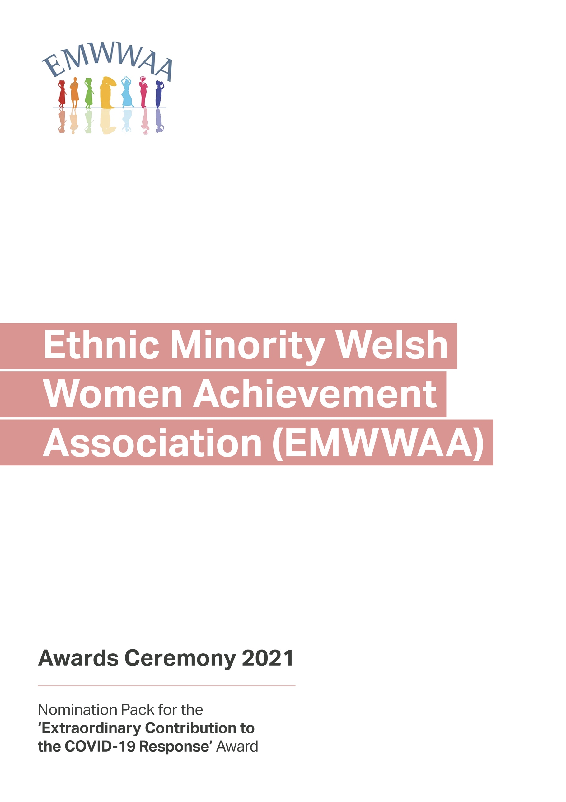
Nominated Candidate Details

Category

Candidate Details

Name:
Address:
City/Post Code:
Telephone: Email:

Work Details

Company:
Address:
City/Post Code:
Telephone: Email:

Nominator

Name:
Address:
City/Post Code:
Telephone: Email:

Work Details

Company:
Address:
City/Post Code:
Telephone: Email:

Nominated Candidate Details

Candidate Biography
(Max 50 words)

Nominated Candidate Details

Information on the candidate describing their achievements
(previous experience, current activities, contribution to charity/community)

Details of candidate’s plans and the reasons why the candidate should be considered for the award.
(Maximum 500 words)
Background:

Achievements:
Nominated Candidate Details

Details of candidate’s plans and the reasons why the candidate should be considered for the award.
(Maximum 500 words)

Why do you think the candidate deserves the award?

What contributions did the candidate make during and post COVID-19 lockdown?
Nominated Candidate Details

First Referee

Name:
Address:
City/Post Code:
Telephone: Email:

Second Referee

Company:
Address:
City/Post Code:
Telephone: Email:

Referees must have known the candidate for at least two years

Have you included?
- A recent photograph (full face) of the candidate
- Supporting evidence for their stated achievements
- Referees

Please return your completed form to:
emwwaanominations@wearecowshed.co.uk

This year, the EMWWAA Award Ceremony will be taking place on Friday 2 July at 6pm. More details to follow.
If you would like to help EMWWAA celebrate the lives and achievements of all the extraordinary women this year, you can become a sponsor. Please get in touch via email
if you would like to support the 2021 awards.

