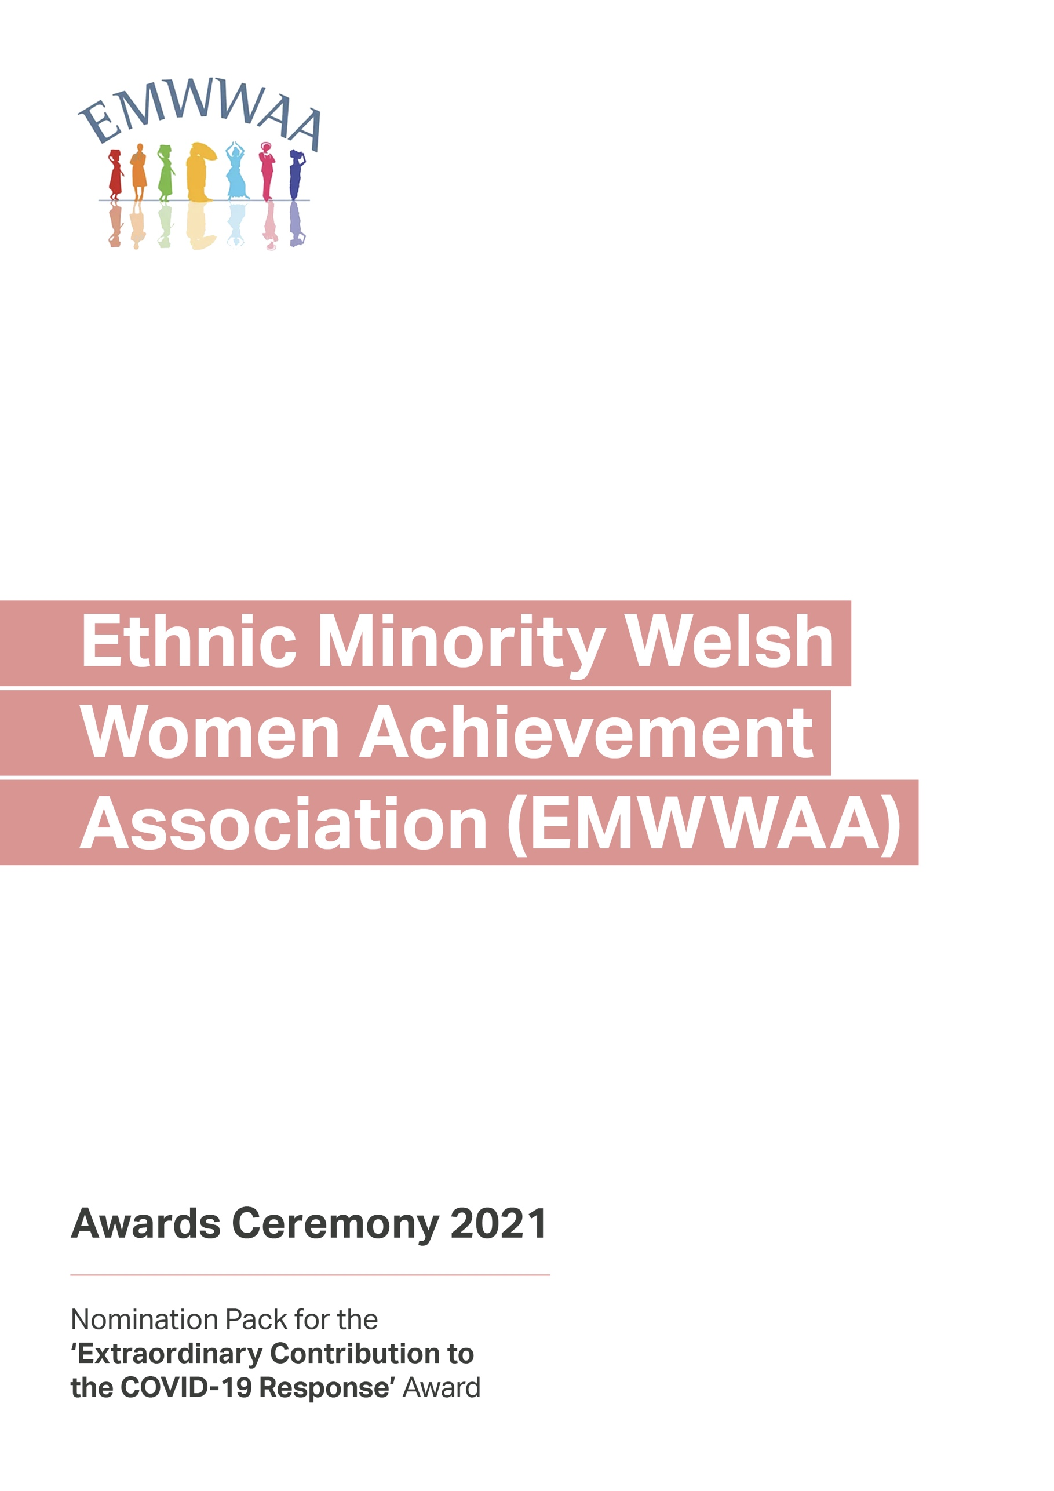
Nominated Candidate Details

Category

Candidate Details

Name:
Address:
City/Post Code:
Telephone: Email:

Work Details

Company:
Address:
City/Post Code:
Telephone: Email:

Nominator

Name:
Address:
City/Post Code:
Telephone: Email:

Work Details

Company:
Address:
City/Post Code:
Telephone: Email:

Nominated Candidate Details

Candidate Biography
(Max 50 words)

Nominated Candidate Details

Information on the candidate describing their achievements
(previous experience, current activities, contribution to charity/community)

Details of candidate’s plans and the reasons why the candidate should be considered for the award. (Maximum 500 words)

Points to consider when answering:

- Covid has been a difficult year for all of us. Can you explain how the workplace/community was impacted by the pandemic?
- What did your nominee do to tackle these challenges?
- Did your nominee encounter any difficulty when seeking to making changes to the workplace/community?
- Please explain and give examples of the work that your nominee has done during the pandemic.
- Please explain how you feel that this work is over and above what is expected of your nominee.
- Can you see your nominee’s work continuing even after the pandemic?
Background (approx. 50 words):

Achievements (approx. 100 words):
Nominated Candidate Details

Details of candidate’s plans and the reasons why the candidate should be considered for the award.
(Maximum 500 words)

Why do you think the candidate deserves the award? (Approx. 150 words)

What contributions did the candidate make during and post COVID-19 lockdown? (Approx. 200 words)
Nominated Candidate Details

First Referee

Name:
Address:
City/Post Code:
Telephone: Email:

Second Referee

Company:
Address:
City/Post Code:
Telephone: Email:

Referees must have known the candidate for at least two years

Have you included?
- A recent photograph (full face) of the candidate
- Supporting evidence for their stated achievements
- Referees

Please return your completed form by midday on Friday 21 May 2021 to:
emwwaanominations@wearecowshed.co.uk

This year, the EMWWAA Award Ceremony will be taking place in September 2021. More details to follow.
If you would like to help EMWWAA celebrate the lives and achievements of all the extraordinary women this year, you can become a sponsor. Please get in touch via email
if you would like to support the 2021 awards.

